Parent Tips to Help with Articulation at Home

Parents,
Your child is working on the ‘sh’ sound. Here is a picture of how your mouth looks while making this sound.

When saying ‘sh’, your teeth are closed and your lips are rounded. Air escapes through the front of your teeth. Please remind your student that this is the “hushing sound”.

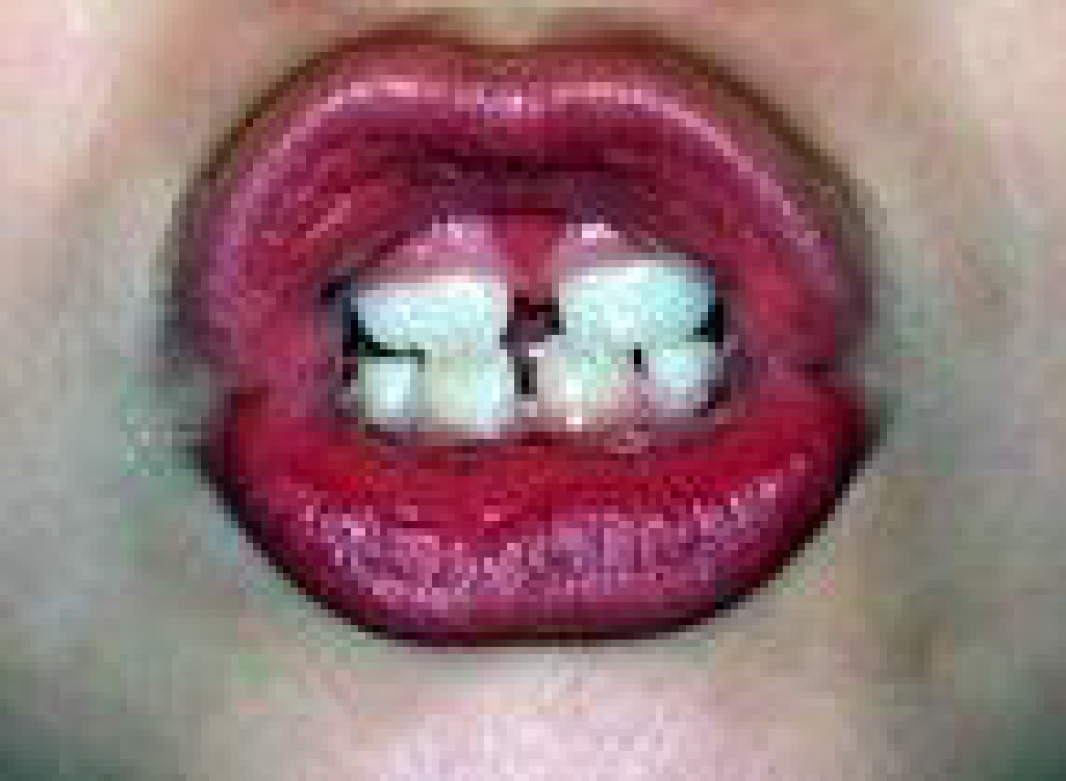

To help your child be more successful at speaking clearly, try these ideas.

1. Review how to make your child’s sound with them.
2. Help your child identify words they have spoken or spelled incorrectly.
3. Model the correct production/spelling of the word for your child.
4. Have your child repeat the correct production.
5. Practice high frequency words using the child’s target sound.
6. Designate a specific time for targeting correct sound production.
7. Complete any home assignments in their speech folder to rehearse their sound use.

If you have any questions or want more ideas, please don’t hesitate to contact:
Mrs. Clark MA, CCC-SLP
Speech-Language Pathologist
330-876-2860 (x117)

