Parent Tips to Help with Articulation at Home

Parent/Guardian,
Your child is working on the /k, g/ sound. Here is a picture of how your mouth looks while making this sound.

When saying /k/ and /g/, the back of your tongue must touch your soft palate. Your soft palate is the “squishy” area on the roof of your mouth. Air builds up behind your tongue and is released as the /k/ or /g/ sound. These sounds are made the same way, but your ‘voice’ is turned on for /g/. If the front of your tongue touches behind your teeth, you will say /t/ or /d/.Please cue your child to “make a mountain” with their tongue tip on the floor of their mouth.

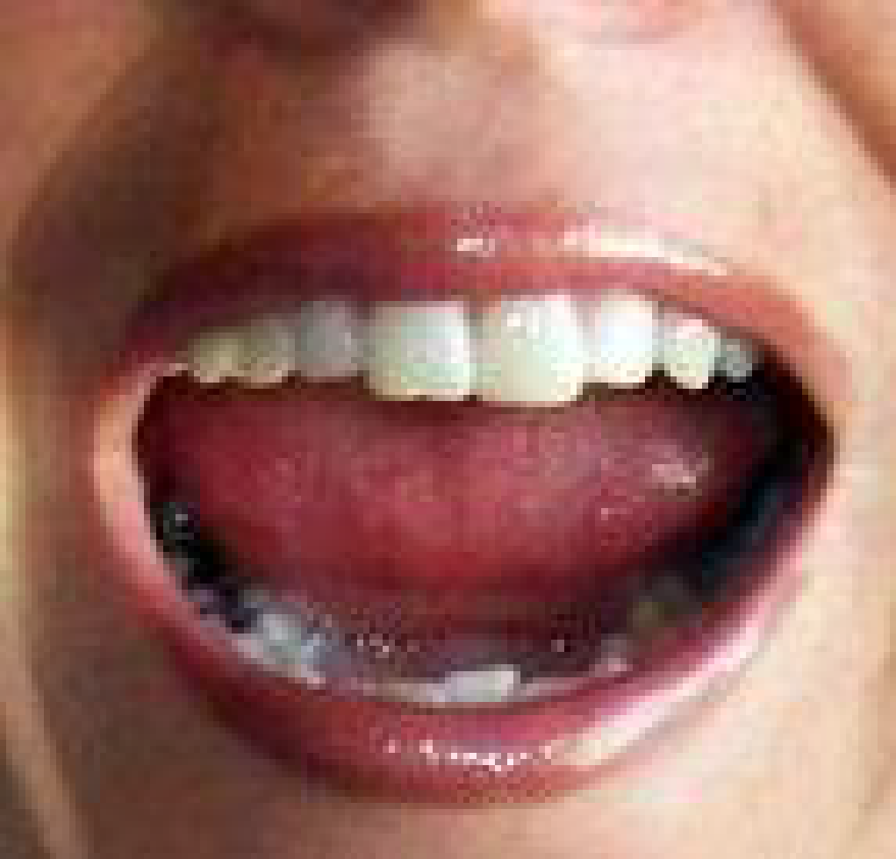

To help your child be more successful at speaking clearly, try these ideas.

1. Review how to make your child’s sound with them.
2. Help your child identify words they have spoken or spelled incorrectly.
3. Model the correct production/spelling of the word for your child.
4. Have your child repeat the correct production.
5. Practice high frequency words using the child’s target sound.
6. Designate a specific time for targeting correct sound production.
7. Complete any home assignments in their speech folder to rehearse their sound use.

If you have any questions or want more ideas, please don’t hesitate to contact:
Mrs. Clark MA, CCC-SLP
Speech-Language Pathologist
330-876-2860 (x117)

