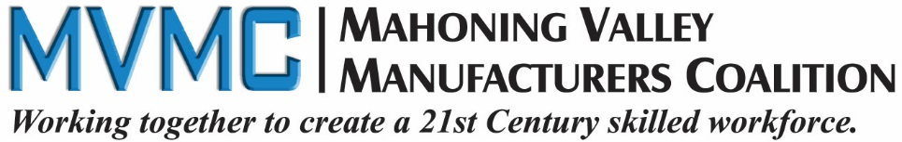

2017 Scholarship Program
5 Scholarships Available!

The Mahoning Valley Manufacturers Coalition (MVMC) was formed in September 2011 by a group of small- and medium-sized, locally-owned manufacturers in Trumbull, Mahoning and Columbiana Counties in Ohio solely for the purpose of “creating educational pathways to meet the needs of member companies for a skilled workforce.”
MVMC is fostering a new, collaborative way of thinking where manufacturers convene, educate, charge and mobilize the region’s key stakeholders to initiate actions that will support manufacturing growth and create career pathways for individuals.

Scholarship Detail
- Scholarships are available to 2017 graduating high school seniors from high schools and/or career and technical centers in Mahoning, Trumbull and Columbiana counties.
- Scholarships are for postsecondary training programs in the fields of machining and welding offered by one of the following career and technical centers or community college that achieve advanced levels of credentials and training. These schools include Columbiana County Career and Technical Center, Trumbull Career & Technical Center or Eastern Gateway Community College.
- There will be five (5) $1,000 scholarships offered.
- One Scholarship Recipient per county (Columbiana, Mahoning, and Trumbull).
- The additional two scholarships can be in any of the tri-counties, based on merit.

Eligibility
High school seniors from Mahoning, Trumbull or Columbiana counties who will be attending a local adult education machining or welding programming at Columbiana County Career & Tech Center, Trumbull Career & Tech Center or Eastern Gateway Community College.

Program Guidelines & Priorities:
Seeking graduating seniors with plans to attend postsecondary training program at one of the regional adult career and technical center (Trumbull Career and Technical Center, Columbiana County Career and Technical Center or Eastern Gateway Community College. Fields of study in machining or welding that achieve advanced levels of credentials and training.

Scholarship funds will be paid prior to the start of the first year programming and will be paid directly to the educational institution and not to the student. It will be the student’s responsibility to submit to the MVMC at that time an invoice for second semester tuition and fees, student ID number and school information.

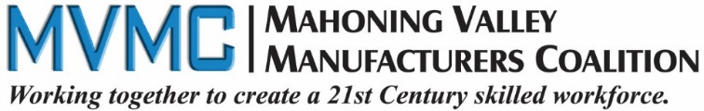
Please complete the scholarship application:
1. | Last Name: | First Name:
2. | Mailing Address  Street:  City: State: Zip:
3. | Daytime Telephone Number: ( )  Email Address:
4. | Date of Birth: Month Day Year Gender:
5. | Cumulative Grade Point Average (GPA): __________ (On a 4.0 scale)  Attach proof of GPA. Your most recent school transcript is required.
6. | Name and location of High School attending:
7. | List any academic honors, awards and membership activities while in high school:
8. | A. If you have decided on the postsecondary school you plan to attend, please list school name:
9.  10. | Name & address of parent(s) or legal guardian(s): (Include address if different than your own listed in Question 2.)  Name(s) :  Street:  City: State: Zip: Telephone:  On a separate sheet please write an essay (250 words) describing why it is important to you to further your education in welding or machining.

Applicants must have the endorsement of their Guidance Counselor on their application attesting they are a qualified fit for this scholarship program. Application deadline is April 21, 2017 by 5 p.m. to be received by MVMC. Late applications are not accepted.
The applications will be reviewed and recipients selected by a committee consisting of Mahoning Valley Manufacturers Coalition members and scholarship announcements will be made in May 2017.
Please submit any questions to: swatson@tpma-inc.com

STATEMENT OF ACCURACY FOR STUDENTS

I hereby affirm that all the above stated information provided by me is true and correct to the best of my knowledge. I also consent that if chosen as a scholarship winner my picture may be taken and used to promote the scholarship program. (Winner may waive photo due to unusual or compelling circumstances.)
I hereby understand that if chosen as a scholarship winner, according to the Mahoning Valley Manufacturers Coalition Scholarship policy, it is my responsibility to remit to the MVMC the appropriate information for my scholarship to be paid directly to my educational institution.

I hereby understand I will not submit this application without all required attachments and supporting information. Incomplete applications or applications that do not meet eligibility criteria will not be considered for this scholarship.

Signature of scholarship applicant: ___________________________________

Date: ___________________

STATEMENT OF SUPPORT BY GUIDANCE COUNSELOR

I hereby affirm that this application meets the criteria set forth by this scholarship program and that I support this application.

Name of Guidance Counselor submitting the application: ____________________________________________

Name of School: _____________________________________________________________________________

Telephone Number: __________________ Email: ___________________________________

Signature of Guidance Counselor: _______________________________________________________________

Date: _________________

Checklist

___ Application

___ Essay

___ Statement of Accuracy signature of student

___ Guidance Counselor signature

___ School Transcript

MAIL COMPLETE APPLICATION PACKAGE TO:

Mahoning Valley Manufacturers Coalition

c/o Sue Watson, MVMC Adm. Asst.

241 W. Federal Street

Youngstown, OH 44503

Requested documentation can be scanned and emailed to swatson@tpma-inc.com

Subject line should read: MVMC Scholarship

REMINDER:
The deadline for this application to be received by MVMC is:
April 21, 2017 by 5 p.m.

